
Please join us


Here you can find us

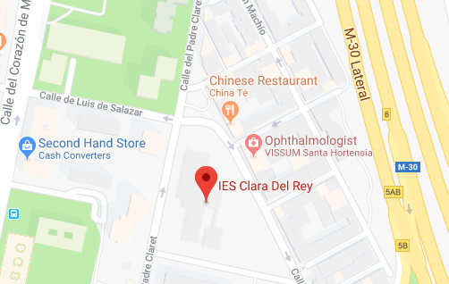

Localization
Street Padre Claret, 8
28002 Madrid
Tel. 915 19 52 57

Merry Christmas
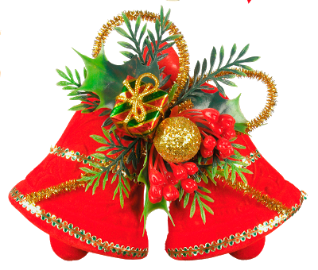
2018

Please join us for a
Christmas Lunch
Wednesday, December 14 Th 2018 at 14:00 A.M
In IES Clara del Rey
Activities



Menú

Appetizers

We start with some skewers of chicken breast with pesto sauce and dried tomato while everyone is sitting down.

Entrante

Soup of fish, a traditional plate of spoon, ideal for this menu in which the products of the sea are the protagonists

Principal plate

For the main course, we have chosen a leg of lamb stuffed with chestnuts, which with its roasted potatoes

Dessert

we have thought of a very light dessert for everyone, so we propose a perfect red fruit Paplova to finish with a very good taste in the mouth.

Our team



- Comunicación: Paola, Paula and Zahira
- Catering: Yamila and Juan Carlos
- Activities: María José, Eva, Maite, Chris



